Attracting beneficial insects
Why would you want to attract bugs and other creepy crawlies into your garden? Because they are the key to having a productive, organic, self-sufficient garden.
We are all aware of the role that bees play in pollination, but other types of insects are also equally important pollinators and service plants that bees don’t. These include wasps, flies, and butterflies.
Then there are the predator insects that manage pests and even diseases in the garden. These predators include dragonflies (eat mosquitoes); ladybirds, hover flies and lacewings (all eat aphids); and praying mantises (eat grasshoppers), to name a few.
To have a healthy garden we need to view it as a whole system, providing habitat not only for birds and lizards but also the insects that they eat and that in turn manage pests and diseases for us. When we support insects, we can avoid chemical management and attract more wildlife into the garden.
Luckily, creating habitat to attract insects into your garden is not only easy but surprisingly beautiful too. If you have been focusing on small bird habitat then you will probably find that you have already started creating habitat for our beneficial insects. Often the plants they like are the same ones we like, and if they like it, then the birds love it! Plant a Bursaria spinosa “Sweet Bursaria” (see notes) and watch it come alive with insects, butterflies and birds. It has a sweet smell and swathes of creamy white flowers. So planting it near a seating area not only creates a lovely scented area but you get front row seats to watching birds flit it and out and butterflies etc hovering around it while you sip you cuppa.
When you start looking at your garden as potential habitat, it brings a completely new dimension to how you perceive and enjoy your garden. Beneficial insects are so named because they help us manage pest and diseases in the garden when we choose them over chemical management.
As Sir David Attenborough said:
"If we and the rest of the back-boned animals were to disappear overnight, the rest of the world would get on pretty well. But if the invertebrates were to disappear, the land's ecosystems would collapse."

As I am based in the ACT, most of my information will focus on relevant insects for the ACT region with links to broader information for other states.
Bees
Over 75% of the world’s flowering plants rely on pollinators like bees to reproduce. Without bees, your garden and the world would look very bare.
Bees are the world’s best pollinators because they collect pollen from flowers to feed their young. Sadly, bee populations around the world are declining even in Australia. As we clear land for urban development, remove plants, create flowerless landscapes and use harmful chemicals on our plants, we cause bee population losses. But you can help by encouraging bees to your garden.
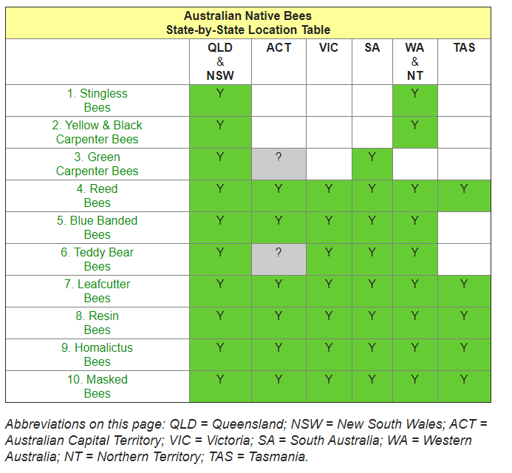
In addition to honey bees and bumble bees (which are introduced), Australia is home to 1,600 different native bee species - there are around 20,000 bee varieties worldwide. Most of these native bees are solitary and live alone, and many don’t make honey, however they are important pollinators for plants. Of the native honey bees, the most productive are also stingless bees, however Canberra is too cool to support them for production purposes.
www.aussiebee.com.au/beesinyourarea.html

Native bees are important pollinators of native flora, most are solitary and while many have stings, they are not aggressive. The blue-banded bee, carpenter bee and teddy bear bee use a method of pollination known as ‘buzz pollination’ or vibrating the flower at a particular frequency while hovering, this prompts the flower to release pollen. This technique is also used by European Honeybees and Bumblebees and has made them active competitors for our native species. As you can see from the table, the ACT is home to quite a few of these remarkable bees, and we can support them in our gardens too (see table).
Reed Bees (Exoneura and Braunsapis)
(Over 80 Australian species)
Reed Bees are slender black bees 5-8 mm long. Some species have a red abdomen. Their name comes from their habitat of nesting in the dried-out stems of plants such as raspberries and blackberries or in the dead fronds of tree ferns. Unfortunately, many nests can also be found in dead canes of the weed species Lantana, and populations can be removed during weed clean-up programs. The adults hibernate inside the stems during winter allowing them to emerge the following spring, rather than dying each year like other Australian bees (Aus Museum 2021).
Blue-banded Bees Amegilla
(15 Australian species)
These bees (mostly 8-13 mm long), with glittering stripes of blue or whitish hair across their black abdomens, are often seen darting around the flowers of lavenders and abelias. It was once thought that they were only attracted to blue and purple flowers, but this is not strictly true although they do seem to prefer these colours and will be attracted to blue clothing and objects.
While essentially a solitary bee, they will build nests close to each other. The females build nests in shallow burrows in the ground but they may also nest in mudbrick houses or in soft mortar. Research has shown that Blue Banded Bees could be valuable pollinators of greenhouse tomatoes
Leafcutter Bees
Megachile
(About 40 Australian species)
Beewatchers often first discover these amazing 6 to 15 mm long bees when they notice rows of neat circular cuts on the edges of some leaves in their garden. Leafcutters use the disks of leaf as a nest building material. They particularly like the soft leaves of roses, Bauhinia and Buddleja.

Resin Bees
Megachile, formerly in genus Chalicodoma
(About 100 Australian species)
Resin Bees come in many colours and sizes. For example there are large black 14 mm bees with white tufts of hair, and small 8 mm black bees with bright orange abdomens. They nest in pre-existing holes or gaps in timber or stonework. They are called Resin Bees because they collect resins and gums to build partitions between their brood cells and to seal their nest holes. Beekeepers sometimes notice Resin Bees hanging around Stingless Bee hives, trying to ‘borrow’ a little resin for their nests. They are common residents in Bee Hotels.
Homalictus Bees
Homalictus
(Over 40 Australian species)
Although very small (most less than 8 mm long), the glittering Homalictus Bees come in a dazzling array of colours. ‘Golden blue’, ‘coppery red’ and ‘green tinged with purple, red or gold’ are just a few of the colours listed by scientists. Homalictus Bees dig intricate branching nests in the ground. Many females may live together in each nest, taking turns to guard the narrow nest entrance. One nest was found to be occupied by over 160 females!
Masked Bees
Amphylaeus, Hylaeus and Meroglossa
(Over 150 Australian species possibly due to the variety of eucalypts they pollinate and nest in)
These slender black bees (range between 3-11 mm long) are called ‘Masked Bees’ because they have pale markings on their faces. Many species also have a distinctive yellow spot on the thorax. Masked Bees have very little hair and carry pollen to their nests by swallowing it. The nests are usually in pithy stems or pre-existing holes in wood. Masked Bees weave their brood cells from an amazing cellophane-like secretion.

Feathery Leioproctus Bee
Scientific name: Leioproctus plumosus
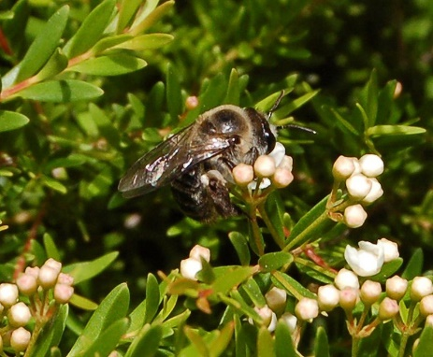
Feathery Leioproctus Bee, Leioproctus (Leioproctus) plumosus (Smith, 1853) Image: Megan Halcroft
© CC BY-NC-SA
- Size Range
8 mm - 14 mm
The Feathery Leioproctus Bee is a member of the largest Australian bee family, the Colletidae, which contains more than half of the known species of native bees.

Identification
The Feathery Leioproctus Bee is very hairy with a metallic green-blue body, head and thorax.

Habitat
The Feathery Leioproctus Bee lives in urban areas with sandy ground, as well as forests and woodlands and heath.

Distribution
The Feathery Leioproctus Bee is found in Queensland, New South Wales, Victoria, South Australia and Western Australia.
The Feathery Leioproctus Bee is a member of the largest Australian bee family, the Colletidae, which contains more than half of the known species of native bees. The family name is Greek in origin and means 'glued'. This come from the way these bees line their nest with a cellophane-like secretion, which hardens after being applied by the females' tongue. Each female digs a solitary tunnel in sandy ground, but many tunnels may occur in the same area. In spring, large numbers of males (which cannot sting) may be seen flying above the nesting areas seeking females, which they locate by scent.
Potentials
Green Carpenter Bees
Xylocopa (Lestis), formerly in genus Lestis
(Two Australian species)
These spectacular bees (up to 17 mm long) are glossy metallic green with tints of yellow or blue. They cut 7 to 10 mm wide nest burrows in the flower stalks of the grass tree (Xanthorrhoea) or in other soft pithy dead timber. They are mainly found in QLD and NSW. Landclearing has caused the loss of these stunning bees from VIC and mainland areas of SA although they can still be found on Kangaroo Island in SA.

Teddy Bear Bees,
Amegilla (Asaropoda)
(About 25 Australian species)
Other states
Stingless Bees
Unfortunately if you want to make honey in the ACT and other cold regions we need to stick with European Honey Bees. Tetragonula* and Austroplebeia
* Previously called Trigona (Eleven Australian species)
Australia’s own native honeybees are tiny (3 - 5 mm), black and stingless! Inside their resinous nest are a queen, males, and hundreds or even thousands of worker bees. They usually nest inside hollow trees but in northern areas they also nest in urban situations such as inside wall cavities or underneath concrete footpaths.
The Stingless Bees are the only native bees currently available for sale in Australia. Beekeepers transfer the nests into small hive boxes and can propagate the nests by splitting. These hives can be used for honey production and crop pollination.
The climate of QLD and the NT is ideal for Stingless Bees because they are tropical species. They also thrive in northern NSW and on the NSW Mid North Coast.
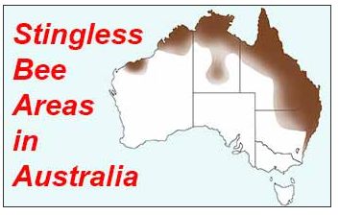
Stingless Bees are found in Sydney, on the eastern side of the Blue Mountains and in coastal areas down to Bega. However, the climate in these areas is marginal for Stingless Bees, and boxed hives need to be carefully sited and managed. Harvesting honey from hives is not recommended in these areas. The bees will not fly below 18 degrees C and they need the excess honey they collect during summer to survive the long winter months.
Stingless Bees are not found in other areas of NSW, in the ACT, in VIC, SA or TAS. Hives would not survive in these areas without special artificial support.
In WA, Stingless Bees are only found from the Hamersley Ranges northwards. Local WA authorities strongly oppose the introduction of Stingless Bees to more southern areas as they may disturb the delicate ecology of the state’s beautiful wildflowers.

The best known bee in Australia is the yellow-brown commercial Honey Bee (Apis mellifera). This is not a native bee, even though it sometimes goes wild and builds nests in our bushland. This bee was introduced to Australia from Europe in about 1822 to produce honey for our pioneers.

NATIVE BEES
Native bees are important pollinators of our native plants; most are solitary, and although most possess stings they are not aggressive. The blue-banded bee, carpenter bee and teddy bear bee use a method of pollinating known as 'buzz pollination' - vibrating the flower at a specific frequency while hovering, which prompts the flower to release pollen.
www.aussiebee.com.au/beesinyourarea.html

Our native bees are beautiful and diverse. Some are covered in thick, furry hair while others are smooth and shiny. Some sport yellow and black stripes while others are blue in colour. They come in a range of sizes too, from the spectacular 24 millimetre carpenter bee to the world’s smallest bee, the 2 millimetre Quasihesma bee.
Bugs
Ladybirds
Ladybirds (also known as Ladybeetles & Ladybugs) eat aphids, scale & mites. Their bright colours are used as a warning for predators, and they excrete a yellow liquid when they are scared that doesn’t taste good to a predator! There are a few common varieties of ladybirds including the more common orange with black spots. This is the one that loves aphids, scale & mites, a very welcomed guest!

The next one is the mealybug ladybird, which eats mealybugs. Then you have the fungus eating ladybird, who helps control black & yellow discoloration on plants by eating the mildew fungus.

You'll spot the unhatched ones as yellow eggs in clusters on the undersides of leaves.
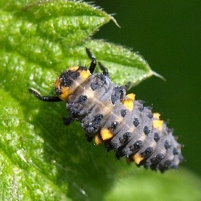
Ladybird lavae

Bad - the 28 spotted ladybird is up to 1cm in length and is light orange with 28 spots on her back. She’s a leaf eater! You may find her on your cabbage, potato or beans. The best way to deal with her is to pick her off.

Lacewing
Lacewings larvae eat aphids, mites, whiteflies, small caterpillars, as well as moth eggs and sometimes mealybug if desperate. They are sometimes called ‘aphid lions’ because of their lack of table manners.
How to detect them
If you spy tiny white dots balanced on hair-like threads, attached to the stem of one of your plants, chances are they're lacewing eggs.
The larvae that emerge will eat most garden pests - aphids, mites, whitefly and insect eggs.
The larvae grow into translucent pale green moth-like insects. Lure helpful bugs like these to your garden by planting the kind of flowers they like - small flat flowers clustered together, so the pollen is easy to reach.

Parastic wasps
Parasitic Wasps lay eggs inside or on living aphids, caterpillars, beetles, scale, and flies! Not the most humane of treatments, however, wasps are a very vital part of the biological process in the garden. Parasitic wasps deposit their eggs inside an adult or larval insect and when the eggs hatch, the offspring will feed on the host insect resulting in the host’s slow death.
Praying mantis
Praying Mantis eats aphids, leafhoppers, mosquitoes, caterpillars, and other soft-bodied insects when young. Later they will eat larger insects, beetles, grasshoppers, crickets, and other pest insects.

Flies
Most of us don’t really like or want to attract flies. However, there are many types of flies, beyond the disgusting blowfly, that are actually quite attractive and not nearly as annoying. Although, all flies (including the disgusting and annoying ones), play important roles in our ecosystems. Recently, we have discovered that flies are responsible for pollination and are considered to be better pollinators than bees, so as bees decline, and potential food production is affected, we may find ourselves turning to flies to step in.

Hoverflies
Hoverflies lay their eggs near aphids. It’s the larvae of the hover-flies which are important predators of pests, such as aphids, scales, thrips, and caterpillars. Once the larvae hatch they feast on the bugs. Hoverflies are known as the helicopters of the insect world and are also important pollinators.
Some hoverflies lay their eggs in stagnant water, where their larvae eat mosquito larvae; and some scavenge in ant nests. Hoverflies are the good guys!

Long legged fly
This shimmery metallic fly with transparent wings and long slender legs preys on smaller leaf-sucking insects like aphids, thrips, and spider mites.

Its larvae live in moist soil and under bark, and eat other (pest) insect larvae.
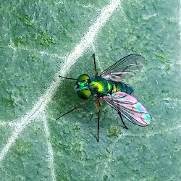

Lastly, butterflies
This is easy. They are beautiful and wonderful to watch. However, their grubs are also responsible for chomping through your favourite plants. Some like the swallowtails may do a bit of damage to your citrus trees, but the damage is reversible and in Australia, this species is in decline due to the use of chemical pesticides.
Slugs and snails
Did you know that not all slugs and snails cause damage in gardens?
In Australia, only introduced species of snails or slugs are pests - none of the native species are a pest. In fact, some native snails are carnivorous and will feed on introduced garden snails.
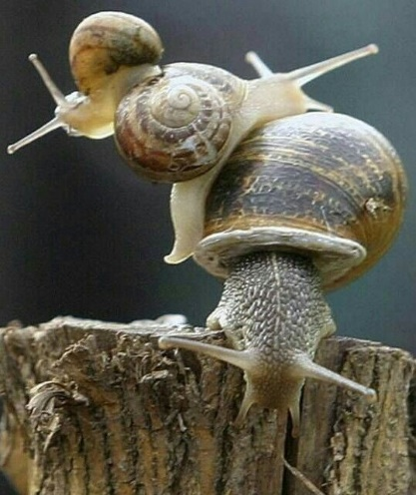
Common Garden Snail
Pest species occur in moister areas across the southern half of Australia. The heavy mulching and watering that is required to maintain growing conditions in many drier parts of the country creates perfect conditions for snails and slugs.
Most damage occurs at night. Snails and slugs hide during the day in soil, under plants and detritus, or in plants. In ideal cool moist conditions, slug and snail numbers can build up quickly because new batches of eggs can be laid every few weeks.
How can you use this knowledge to prevent the detrimental species form invading your garden? Try tidying up piles of pots and timber to minimise daytime hiding places. Check under the rims of pots, remove weeds behind sheds and in shady back corners, as these are perfect breeding areas. A damp hessian sack or newspaper attracts slugs and snails to shelter beneath it. Check it in the morning and collect and dispose of any pests found.
The other important point is that the vulnerability of plants to most pests, especially slugs and snails, is greatest when they are first emerging as seedlings, or unfurling buds in spring. Protection and vigilance need to be greatest at this time. Sometimes it’s best to start plants in pots to get them large enough to give them the resources to cope with a nibbling.

Planting for Predators
Plants that produce umbel-shaped flowers are magnets for pest-controlling predators.
An umbel is a flower form where the flower stalks radiate from a central point. There are two different types. Flat-headed forms include angelica, parsley and dill. The round-headed forms are often found in onions, spring onions, chives, garlic and even the ornamental onions.
It's the silhouette of either type of flower that attracts the beneficial predatory insects. They know the shape promises pollen and nectar - and even an easy landing platform for smaller insects.

Flowers and herbs for pollinators
Help native fauna find a safe haven in your garden. These plants are essential for beneficial insects to feed on; and many have attractive flowers or fragrant leaves for us to enjoy.
Plant them separately, or in this Good Bug mix of herbs and cover crops
• alyssum • bergamot • carrot • coriander • cosmos • daisies • dill • fennel • lavender • lemon balm • lobelia • mint • parsley • pea • poached egg plant • rudbeckia • statice • veronica • zinnia

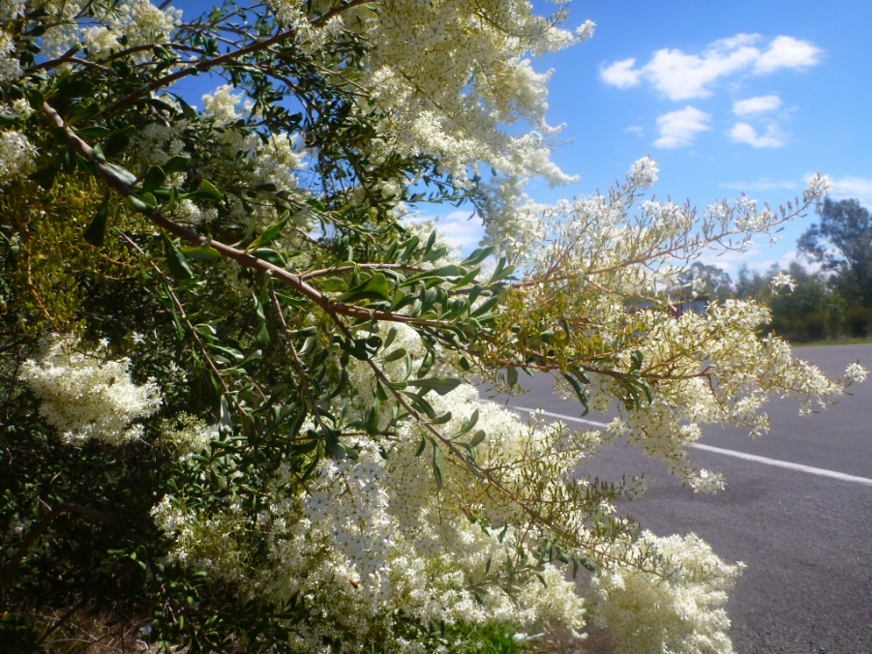
Plants that produce abundant nectar will attract insects and birds alike, some extraordinary examples includes this native Bursaria spinosa ‘Sweet Busaria’ or

Habitat – general
Plants that attract them into your garden will normally be food plants so to keep them there find ways to encourage their reproductive cycle too. Leaf litter and mulch provide habitat for most insects and facilitate some stages of their lifecycle. Some plants are preferred for the insects grubs/larvae so having some sacrificial plants in the garden for this will help encourage them in.
CREATE A BEE HABITAT GARDEN
Bees are after one thing and that’s the food in flowers: pollen and nectar. So the more flowers in your garden, the more bees you’ll attract.
But some flowers are more attractive to bees than others. This is because they may have more pollen and nectar, they may flower at a time when there aren’t many other plants in flower or the flower structure may simply be better for landing and feasting.
By planting a mix of plants, which flower throughout the year, you are giving bees a regular food supply. This will encourage them to stay, feed, drink, shelter and even reproduce in your garden.
Most native bees have cleverly evolved to collect pollen and nectar from native and non-native flowering plants, making them ‘generalist’ foragers. But there are around 100 species of native bees that are specialist bees, so it’s worth planting a handful of native plants in your garden too. For the full list of plant species check out (www.flowerpower.com.au/garden-advice/gardening/4-simple-ways-to-attract-native-bees).
Rather than scattering flowers randomly, plant large patches. This encourages bees to forage and cross pollinate the plants as they move efficiently from flower to flower.
Water – provide water using a bowl filled with pebbles with the water level just at the surface. Bees love a drink, but they drown easily so make sure there is something to perch on while drinking.
Shelter - Native bees don’t build the structures we associate with honeybees, but they do need places to nest, which vary depending on the species.
Resin and leafcutter bees will nest in large drilled holes in wood, which mimic the natural cavities produced by wood-boring insects. Resin bees also like to shelter in small cavities in rockeries or layers of rolled bark. Hollow stems can be bundled up to attract reed and masked bees.
In Australia, we’re encouraged to mulch our plants, but native bees that nest in the ground find it hard to dig through thick layers of mulch. So leave an area of bare ground, at least a metre squared, to encourage ground-nesting bees into your garden.

Butterflies
Butterflies like to warm up in the morning basking on rocks and bare patches of soil.

Plant native shrubs for habitat
A few of our rare butterflies only feed on a small number of local native plants, and with increased development and construction, these plants are disappearing in the wild.
The same goes for native bees, and other fauna which are all suffering from loss of habitat.

• acacia • banksia • bottlebrush (Callistemon) • brush box (Lophostemon) • eucalyptus • flowering gum (Corymbia, Eucalyptus) • grevillea • hardenbergia • tea tree (Leptospermum) • melaleuca • myoporum • native violet (Viola hederacea) • pandorea

References

https://familygardenlife.com/top-benefical-insects-australia
www.abc.net.au/gardening/factsheets/enticing-the-insects/9435932
www.australianplantsonline.com.au/blog/post/good-bugs-beneficial-insects
www.flowerpower.com.au/garden-advice/gardening/4-simple-ways-to-attract-native-bees

Beneficials bugs fall into different categories
Parasitoides
There are lots of other insect predators in your garden: dragonflies eating mosquitoes; ladybirds, hover flies and lacewings all eating aphids; and preying mantis eating grasshoppers.
You’ll be pleased to learn that things that are food or shelter for one species, are usually food and shelter for many. Taking the adage “two birds one stone” to much more positive heights. For example, Bursaria spinosa “Sweet bursaria” provides shelter and food (seeds and nectar) for birds, and nectar for butterflies and insects, as well as being sweet smelling and attractive to humans.

Bees
Why is attracting bees to your garden important? These valuable little visitors pollinate many of your plants. In fact, over 75% of the world’s flowering plants rely on pollinators like bees to reproduce. Without bees, your garden and the world would look very bare.
Bees are the world’s best pollinators because they collect pollen from flowers to feed their young. Sadly bee populations in Australia and around the world are declining. As we clear land for urban development, remove plants, create flowerless landscapes and use harmful chemicals on our plants, we cause bee population losses. The good news is you can help, by encouraging bees to your garden.
NATIVE BEES
Native bees are important pollinators of our native plants; most are solitary, and although most possess stings they are not aggressive. The blue-banded bee, carpenter bee and teddy bear bee use a method of pollinating known as 'buzz pollination' - vibrating the flower at a specific frequency while hovering, which prompts the flower to release pollen.
Australia is home to 1,600 different native bee species - there are around 20,000 bee varieties worldwide. Most of these native bees are solitary and live alone, and although they don’t make honey, they are important pollinators.
Our native bees are beautiful and diverse. Some are covered in thick, furry hair while others are smooth and shiny. Some sport yellow and black stripes while others are blue in colour. They come in a range of sizes too, from the spectacular 24 millimetre carpenter bee to the world’s smallest bee, the 2 millimetre Quasihesma bee.
Bugs
Ladybirds
Ladybirds (also known as Ladybeetles & Ladybugs) eat aphids, scale & mites. Their bright colours are used as a warning for predators, and they excrete a yellow liquid when they are scared that doesn’t taste good to a predator! There are a few common varieties of ladybirds including the more common orange with black spots. This is the one that loves aphids, scale & mites, a very welcomed guest!

The next one is the mealybug ladybird, which eats mealybugs. Then you have the fungus eating ladybird, who helps control black & yellow discoloration on plants by eating the mildew fungus.

You'll spot the unhatched ones as yellow eggs in clusters on the undersides of leaves.
Ladybird lavae

Bad - the 28 spotted ladybird is up to 1cm in length and is light orange with 28 spots on her back. She’s a leaf eater! You may find her on your cabbage, potato or beans. The best way to deal with her is to pick her off.

Lacewing
Lacewings larvae eat aphids, mites, whiteflies, small caterpillars, as well as moth eggs and sometimes mealybug if desperate. They are sometimes called ‘aphid lions’ because of their lack of table manners.
How to detect them
If you spy tiny white dots balanced on hair-like threads, attached to the stem of one of your plants, chances are they're lacewing eggs.
The larvae that emerge will eat most garden pests - aphids, mites, whitefly and insect eggs.
The larvae grow into translucent pale green moth-like insects. Lure helpful bugs like these to your garden by planting the kind of flowers they like - small flat flowers clustered together, so the pollen is easy to reach.

Parastic wasps
Parasitic Wasps lay eggs inside or on living aphids, caterpillars, beetles, scale, and flies! Not the most humane of treatments, however, wasps are a very vital part of the biological process in the garden. Parasitic wasps deposit their eggs inside an adult or larval insect and when the eggs hatch, the offspring will feed on the host insect resulting in the host’s slow death.
Praying mantis
Praying Mantis eats aphids, leafhoppers, mosquitoes, caterpillars, and other soft-bodied insects when young. Later they will eat larger insects, beetles, grasshoppers, crickets, and other pest insects.

Flies
Most of us don’t really like or want to attract flies. However, there are many types of flies, beyond the disgusting blowfly, that are actually quite attractive and not nearly as annoying. Although, all flies (including the disgusting and annoying ones), play important roles in our ecosystems. Recently, we have discovered that flies are responsible for pollination and are considered to be better pollinators than bees, so as bees decline, and potential food production is affected, we may find ourselves turning to flies to step in.

Hoverflies
Hoverflies lay their eggs near aphids. It’s the larvae of the hover-flies which are important predators of pests, such as aphids, scales, thrips, and caterpillars. Once the larvae hatch they feast on the bugs. Hoverflies are known as the helicopters of the insect world and are also important pollinators.
Some hoverflies lay their eggs in stagnant water, where their larvae eat mosquito larvae; and some scavenge in ant nests. Hoverflies are the good guys!

Long legged fly
This shimmery metallic fly with transparent wings and long slender legs preys on smaller leaf-sucking insects like aphids, thrips, and spider mites.

Its larvae live in moist soil and under bark, and eat other (pest) insect larvae.

Lastly, butterflies
This is easy. They are beautiful and wonderful to watch. However, their grubs are also responsible for chomping through your favourite plants. Some like the swallowtails may do a bit of damage to your citrus trees, but the damage is reversible and in Australia, this species is in decline due to the use of chemical pesticides.
Slugs and snails
Did you know that not all slugs and snails cause damage in gardens?
In Australia, only introduced species of snails or slugs are pests - none of the native species are a pest. In fact, some native snails are carnivorous and will feed on introduced garden snails.
Common Garden Snail
Pest species occur in moister areas across the southern half of Australia. The heavy mulching and watering that is required to maintain growing conditions in many drier parts of the country creates perfect conditions for snails and slugs.
Most damage occurs at night. Snails and slugs hide during the day in soil, under plants and detritus, or in plants. In ideal cool moist conditions, slug and snail numbers can build up quickly because new batches of eggs can be laid every few weeks.
How can you use this knowledge to prevent the detrimental species form invading your garden? Try tidying up piles of pots and timber to minimise daytime hiding places. Check under the rims of pots, remove weeds behind sheds and in shady back corners, as these are perfect breeding areas. A damp hessian sack or newspaper attracts slugs and snails to shelter beneath it. Check it in the morning and collect and dispose of any pests found.
The other important point is that the vulnerability of plants to most pests, especially slugs and snails, is greatest when they are first emerging as seedlings, or unfurling buds in spring. So protection and vigilance need to be greatest at this time. Last year I sowed at least 100 sunflower seeds in the flower garden - not a single one survived! So this year they are being started in pots to get them large enough to give them the resources to cope with a nibbling.

Planting for Predators
Plants that produce umbel-shaped flowers are magnets for pest-controlling predators.
An umbel is a flower form where the flower stalks radiate from a central point. There are two different types. Flat-headed forms include angelica, parsley and dill. The round-headed forms are often found in onions, spring onions, chives, garlic and even the ornamental onions.
It's the silhouette of either type of flower that attracts the beneficial predatory insects. They know the shape promises pollen and nectar - and even an easy landing platform for smaller insects.

Plant flowers and herbs for pollinators
Help native fauna find a safe haven in your garden. These plants are essential for beneficial insects to feed on; and many have attractive flowers or fragrant leaves for us to enjoy.
Plant them separately, or in this Good Bug mix of herbs and cover crops

• alyssum • bergamot • carrot • coriander • cosmos • daisies • dill • fennel • lavender • lemon balm • lobelia • mint • parsley • pea • poached egg plant • rudbeckia • statice • veronica • zinnia

Habitat – general
Plants that attract them into your garden will normally be food plants so to keep them there find ways to encourage their reproductive cycle too. Leaf litter and mulch provide habitat for most insects and facilitate some stages of their lifecycle. Some plants are preferred for the insects grubs/larvae so having some sacrificial plants in the garden for this will help encourage them in.
CREATE A BEE HABITAT GARDEN
Bees are after one thing and that’s the food in flowers: pollen and nectar. So the more flowers in your garden, the more bees you’ll attract.
But some flowers are more attractive to bees than others. This is because they may have more pollen and nectar, they may flower at a time when there aren’t many other plants in flower or the flower structure may simply be better for landing and feasting.
By planting a mix of plants, which flower throughout the year, you are giving bees a regular food supply. This will encourage them to stay, feed, drink, shelter and even reproduce in your garden.
Most native bees have cleverly evolved to collect pollen and nectar from native and non-native flowering plants, making them ‘generalist’ foragers. But there are around 100 species of native bees that are specialist bees, so it’s worth planting a handful of native plants in your garden too. For the full list of plant species check out (www.flowerpower.com.au/garden-advice/gardening/4-simple-ways-to-attract-native-bees).
Rather than scattering flowers randomly, plant large patches. This encourages bees to forage and cross pollinate the plants as they move efficiently from flower to flower.
Water – provide water using a bowl filled with pebbles with the water level just at the surface. Bees love a drink, but they drown easily so make sure there is something to perch on while drinking.
Shelter - Native bees don’t build the structures we associate with honeybees, but they do need places to nest, which vary depending on the species.
Resin and leafcutter bees will nest in large drilled holes in wood, which mimic the natural cavities produced by wood-boring insects. Resin bees also like to shelter in small cavities in rockeries or layers of rolled bark. Hollow stems can be bundled up to attract reed and masked bees.
In Australia, we’re encouraged to mulch our plants, but native bees that nest in the ground find it hard to dig through thick layers of mulch. So leave an area of bare ground, at least a metre squared, to encourage ground-nesting bees into your garden.

Butterflies
Butterflies like to warm up in the morning basking on rocks and bare patches of soil.

Plant native shrubs for habitat
A few of our rare butterflies only feed on a small number of local native plants, and with increased development and construction, these plants are disappearing in the wild.
The same goes for native bees, and other fauna which are all suffering from loss of habitat.

• acacia • banksia • bottlebrush (Callistemon) • brush box (Lophostemon) • eucalyptus • flowering gum (Corymbia, Eucalyptus) • grevillea • hardenbergia • tea tree (Leptospermum) • melaleuca • myoporum • native violet (Viola hederacea) • pandorea

References

https://familygardenlife.com/top-benefical-insects-australia
www.abc.net.au/gardening/factsheets/enticing-the-insects/9435932
www.australianplantsonline.com.au/blog/post/good-bugs-beneficial-insects
www.flowerpower.com.au/garden-advice/gardening/4-simple-ways-to-attract-native-bees

